rails _2.1.0_ new myapp

*Scaffold:

**Rails g scaffold car make color year: integer**

Will create migration, models, resource_route, controller, and view etc.



Applying scaffolding to DB

**Rake db:migrate**

Rails uses SQLite for database by default



\***Using database console: rails db**

Rails db

.help for usage hints

.tables

cars schema_migrations

.headers on

.mode columns

Select * from cars; //will show the database content

.exit to exit

**Migrations**



Ruby classes that extend ActiveRecord::Migration

File name needs to start with a timestamp (year/month/ date/hour/minute/second) and be followed by some name, which becomes the name of the class

This timestamp defines the sequence of how the migrations are applied and acts as a database version of sorts or snapshot in time

**Creating Migrations**  
1. Create migrations by hand, but it’s better to use a generator.

2. scaffold

3. explicit migration generator

Applying Migrations

Rake db:migrate

To apply all migrations in db/migrate folder in (timestamp) order

How it works

1. Migration code maintains a table called schema_migrations table with one column called version
2. Once the migration is applied – its version (timestamp) goes into the schema_migrations table
3. It therefore follows that running db:migrate (on the same set of migrations) multiple times will have no effect

Anatomy of Migration

* def up

Generate db schema change

* def down

Undo the changes introduced by the up method

We can use change method when rails can guess how to undo changes (most of the time)

Database Independence

Instead of specifying database-specific types for particular DB type ¨C migrations let you specify logical database types

The ruby database adapter you are using does the translation to the actual DB type.

So, for MySQL – it will end up being one type, Postgres another and so on.

Adding / Removing Column

add_column :table_name, :column_name, :column_type

remove_column :table_name, :column_name

Add price to cars table

Rails g migration add_price_to_cars ‘price:decimal{10,2}’

ActiveRecord::Schema.define(version: 20150907202117) do

create_table "cars", force: :cascade do |t|

t.string "company"

t.string "color"

t.integer "year"

t.datetime "created_at", null: false

t.datetime "updated_at", null: false

t.decimal "price", precision: 10, scale: 2

end

Renaming columns

Rails g migration rename_make_to_company





rename_column :table_name, :old_column_name, :new_column_name

Dynamic

**class** Store

**def** get_piano_desc

**"Excellent piano"**

**end**

**def** get_piano_price

120.00

**end**

**def** get_violin_desc

**"Fantastic violin"**

**end**

**def** get_violin_price

110.00

**end**

*# ...many other similar methods...*

**end**

require_relative **'store'**

**class** ReportingSystem

**def** initialize

**@store** = Store.new

**end**

**def** get_piano_desc

**@store**.get_piano_desc

**end**

**def** get_piano_price

**@store**.get_piano_price

**end**

*# ...many more simimlar methods...*

**end**

rs = ReportingSystem.new

puts **"**#{rs.get_piano_desc} **costs** #{rs.get_piano_price.to_s.ljust(6, **'0'**)}**"**

*#* ***=> Excellent piano costs 120.00***

Calling Methods Dynamically

**class** Dog

**def** bark

puts **"Woof, woof!"**

**end**

**def** greet(greeting)

puts greeting

**end**

**end**

dog = Dog.new

dog.bark *#* ***=> Woof, woof!***

dog.send(**"bark"**) *#* ***=> Woof, woof!***

dog.send(**:bark**) *#* ***=> Woof, woof!***

method_name = **:bark**

dog.send method_name *#* ***=> Woof, woof!***

dog.send(**:greet**, **"hello"**) *#* ***=> hello***



Defining methods dynamically

**define_method :method_name** and a block which

contains the method definition

**class** Whatever

define_method **:make_it_up do**

puts **"Whatever..."**

**end**

**end**

whatever = Whatever.new

whatever.make_it_up *#* ***=> Whatever...***

So Now, Instead of This…

require_relative **'store'**

**class** ReportingSystem

**def** initialize

**@store** = Store.new

**end**

**def** get_piano_desc

**@store**.get_piano_desc

**end**

**def** get_piano_price

**@store**.get_piano_price

**end**

*# ...many more similar methods...*

**end**

rs = ReportingSystem.new

puts **"**#{rs.get_piano_desc} **costs** #{rs.get_piano_price.to_s.ljust(6, **'0'**)}**"**

*#* ***=> Excellent piano costs 120.00***

We Can Do This!

require_relative **'store'**

**class** ReportingSystem

**def** initialize

**@store** = Store.new

**@store**.methods.grep(**/^get_(.*)_desc/**) { ReportingSystem.define_report_methods_for **$1** }

**end**

**def self**.define_report_methods_for (item)

define_method(**"get_**#{item}**_desc"**) { **@store**.send(**"get_**#{item}**_desc"**)}

define_method(**"get_**#{item}**_price"**) { **@store**.send(**"get_**#{item}**_price"**)}

**end**

**end**

rs = ReportingSystem.new

puts **"**#{rs.get_piano_desc} **costs** #{rs.get_piano_price.to_s.ljust(6, **'0'**)}**"**

*#* ***=> Excellent piano costs 120.00***

Ghost methods

method_missing… method

2 Ruby looks for the method invoked in the class to which

it belongs

2 Then it goes up the ancestors tree (classes and

modules)

2 If it still doesn’t find the method, it calls

method_missing method

2 The default method_missing implementation throws

NoMethodError

Overriding method_missing

2 Since method_missing is just a method, you can

easily override it

2 You have access to

• Name of the method called

• Any arguments passed in

• A block if it was passed in

Overriding method_missing

**class** Mystery

*# no_methods defined*

**def** method_missing (method, *args)

puts **"Looking for..."**

puts **"\"**#{method}**\" with params (**#{args.join(**','**)}**) ?"**

puts **"Sorry... He is on vacation..."**

**yield "Ended up in method_missing" if** block_given?

**end**

**end**

m = Mystery.new

m.solve_mystery(**"abc"**, 123123) **do** |answer|

puts **"And the answer is:** #{answer}**"**

**end**

*#* ***=> Looking for...***

*#* ***=> "solve_mystery" with params (abc,123123) ?***

*#* ***=> Sorry... He is on vacation...***

*#* ***=> And the answer is: Ended up in method_missing***

Struct and OpenStruct

2 Struct

• Generator of specific classes, each one of which is defined

to hold a set of variables and their accessors (“Dynamic

Methods”)

2 OpenStruct

• Object (similar to Struct) whose attributes are created

dynamically when first assigned (“Ghost methods”)

Struct and OpenStruct

Customer = Struct.new(**:name**, **:address**) **do** *# block is optional*

**def** to_s

**"**#{name} **lives at** #{address}**"**

**end**

**end**

jim = Customer.new(**"Jim"**, **"-1000 Wall Street"**)

puts jim *#* ***=> Jim lives at -1000 Wall Street***

require **'ostruct'** *#* ***=> need to require ostruct for OpenStruct***

some_obj = OpenStruct.new(name: **"Joe"**, age: 15)

some_obj.sure = **"three"**

some_obj.really = **"yes, it is true"**

some_obj.not_only_strings = 10

puts **"**#{some_obj.name} #{some_obj.age} #{some_obj.really}**"**

*#* ***=> Joe 15 yes, it is true***

So Now, Instead Of This…

require_relative **'store'**

**class** ReportingSystem

**def** initialize

**@store** = Store.new

**end**

**def** get_piano_desc

**@store**.get_piano_desc

**end**

**def** get_piano_price

**@store**.get_piano_price

**end**

*# ...many more simimlar methods...*

**end**

rs = ReportingSystem.new

puts **"**#{rs.get_piano_desc} **costs** #{rs.get_piano_price.to_s.ljust(6, **'0'**)}**"**

*#* ***=> Excellent piano costs 120.00***

…We Can Do This!

require_relative **'store'**

**class** ReportingSystem

**def** initialize

**@store** = Store.new

**end**

**def** method_missing(name, *args)

**super unless @store**.respond_to?(name)//”super” if store doesn’t have this method throw an error message

**@store**.send(name)

**end**

**end**

rs = ReportingSystem.new

puts **"**#{rs.get_piano_desc} **costs** #{rs.get_piano_price.to_s.ljust(6, **'0'**)}**"**

*#* ***=> Excellent piano costs 120.00***

method_missing and Performance

2 Since the invocation is indirect, could be a little slower

2 Most of the time, it will probably not matter too much

2 If it does, you can consider a hybrid approach

• Define a real method from inside method_missing after

an attempted “call

Summary

2 Ghost methods allow you to call methods as if they are

there even though they are not

2 Method behavior can be defined at runtime, for example

based on database columns existing or not!

**What’s Next?**

2 Introduction to Active Record

**Active Record**

ActiveRecord

 Three Prerequisites:

1. ActiveRecord has to know how to find your database (when Rails

is loaded, this info is read from config/database.yml file)

2. (*Convention*) There is a table with a plural name that corresponds

to ActiveRecord::Base subclass with a singular name

3.(*Convention*) Expects the table to have a primary key named id

Rails Console: rails c

“IRB on steroids” with your Rails App loaded

Car.column_names will show all columns for this class

Model and Migration

Rails g model person first_name last_name



Smart enough to know that the table name is

**people** not persons



Reloading Rails Console

Don’t have to kill rails console after a new migration – just

call reload!

Summary

Active Record conventions:

• Class name is singular

• DB table name is plural

• Need to have an id primary key

Active Record CRUD

Create

Retrieve

Create (***C***RUD)

Three ways to create a record in the database

1. Use an empty constructor and (ghost) attributes to set

the values and then call save

2. Pass a hash of attributes into the constructor and then

call save

3. Use create method with a hash to create an object and

save it to the database in one step

todolistx = TodoList.new(:list_name=>"luke",:list_due_date=>Date.today)

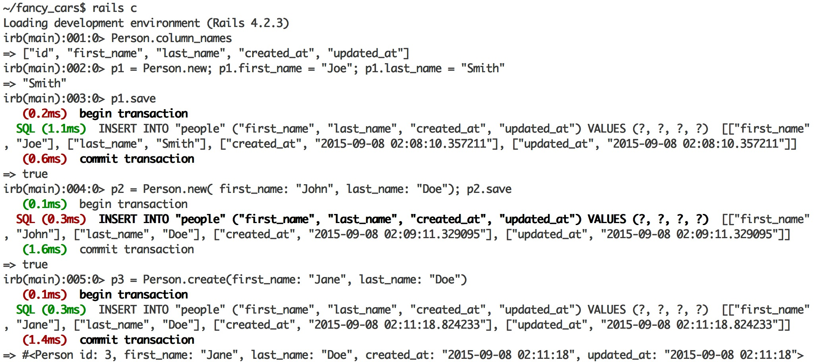

Retrieve / Read (C***R***UD)

2 find(id) or find(id1, id2)

• Throws a RecordNotFound exception if not found

2 first, last, take, all

• Return the results you expect or nil if nothing is found

2 order(:column) or order(column: :desc)

• Allows ordering of the results. Ascending or descending

2 pluck

• Allows to narrow down which fields are coming back

• Need to call at the end!

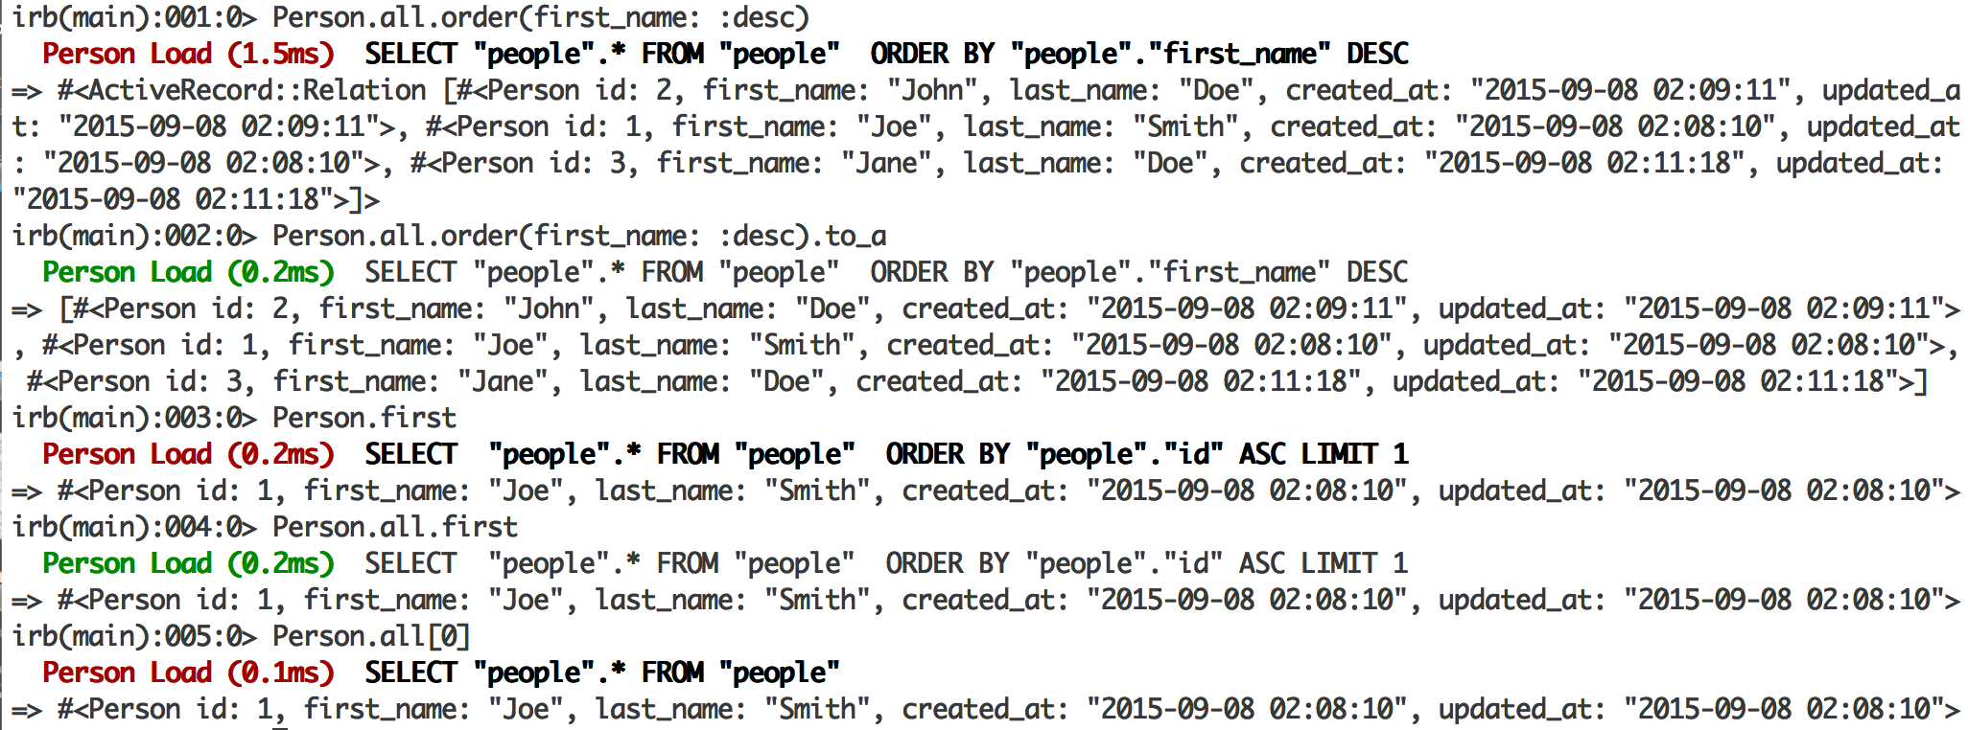

1. Not an array it’s a chain relation Active Record object
2. Use .to_a to convert it into array
3. Get the first object out of people database
4. Query all person objects from database, then get the first objects out of the array, bad performance.

Take and Pluck

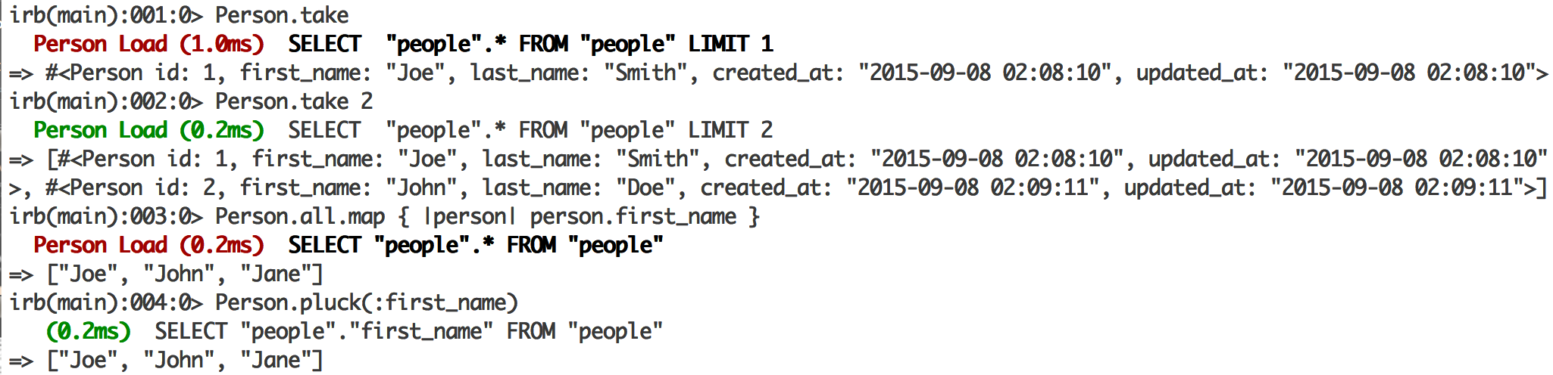

1. Radomly choose 1 objects from “people” database
2. Choose 2 objects
3. Query and turn all objects from DB, and then map
4. Query and return only the result of :first_name

.

Retrieve / Read (C*R*UD)

2 where(hash)

• Enables you to supply conditions for your search

• Returns ActiveRecord::Relation (same as all), but

you can always narrow it down with first or treat it like

an Array…

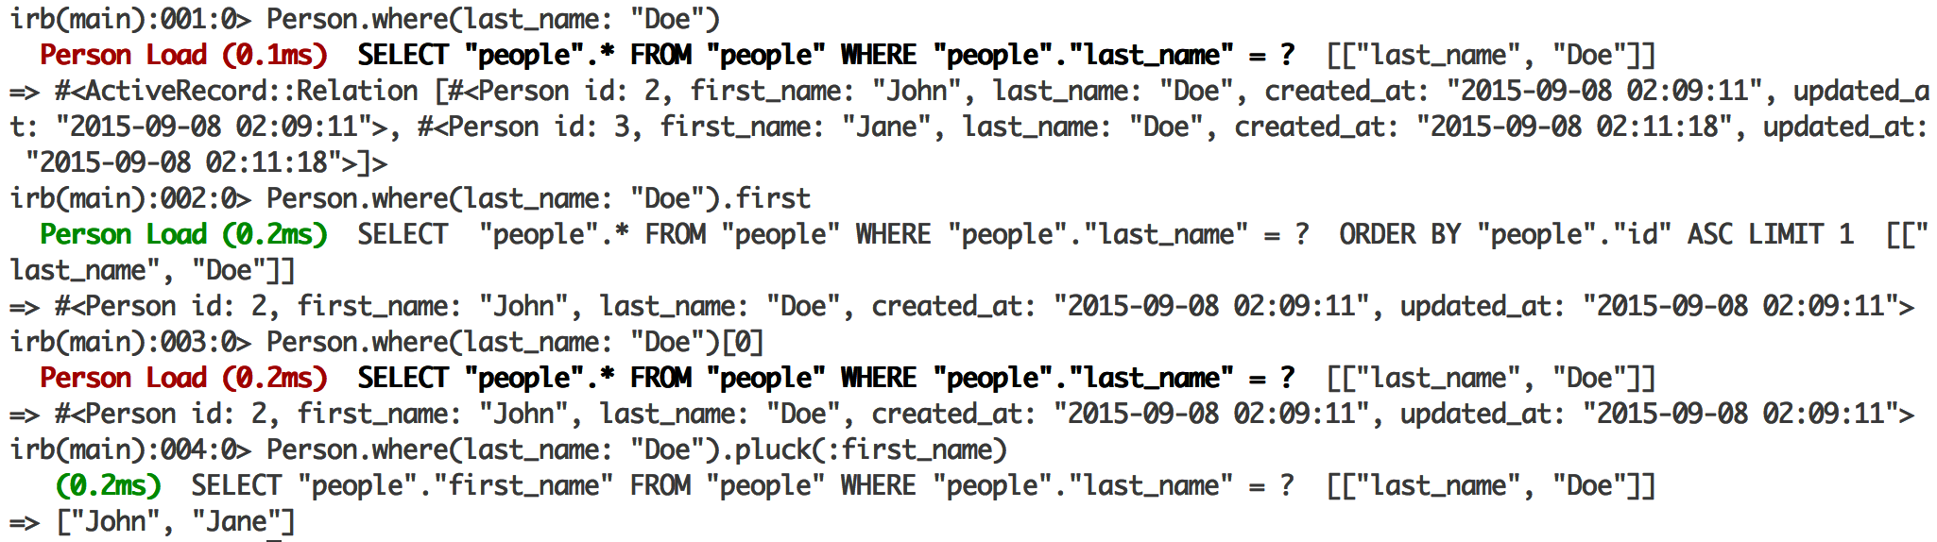

1. Return objects with last_name == “doe”
2. Return the first object with last_name == “doe”
3. Return all objects with last_name == “doe” and select the first object
4. Use [pluck](https://apidock.com/rails/ActiveRecord/Calculations/pluck) as a shortcut to select one or more attributes without loading a bunch of records just to grab the attributes you want

Find_by

2 find_by(conditions_hash)

• Same as where, but returns a single result or nil if a

record with the specified conditions is not found

2 find_by!(conditions_hash)

• Same as find_by, but throws an exception if cannot find

the result

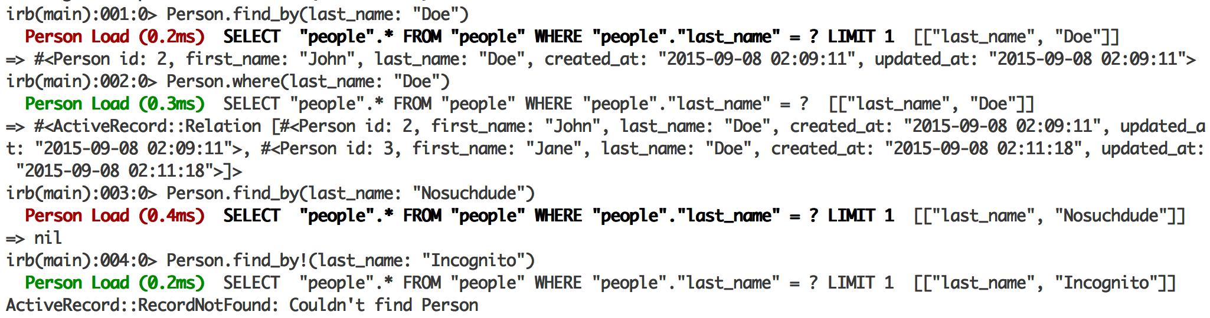

limit / offset

2 limit(n)

• Enables you to limit how many records come back

2 offset(n)

• Don’t start from the beginning; skip a few

2 You can combine these two to “page” through large

collections of records in your database

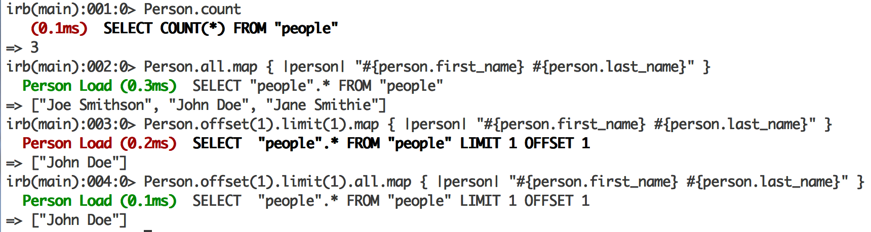

Summary

2 ActiveRecord is very intuitive when it comes to interacting

with a database

2 Always keep in mind if you are getting back a single result

(find) or an ActiveRecord::Relation (where)

Active Record **CRUD**

• **U**pdate

• **D**elete

Update (CR*U*D)

2 Two ways to update a record in the database:

1. Retrieve a record, modify the values and then call save

2. Retrieve a record and then call update method passing

in a hash of attributes with new values

2 There is also update_all for batch updates

• You can chain this to the end of where

Update:

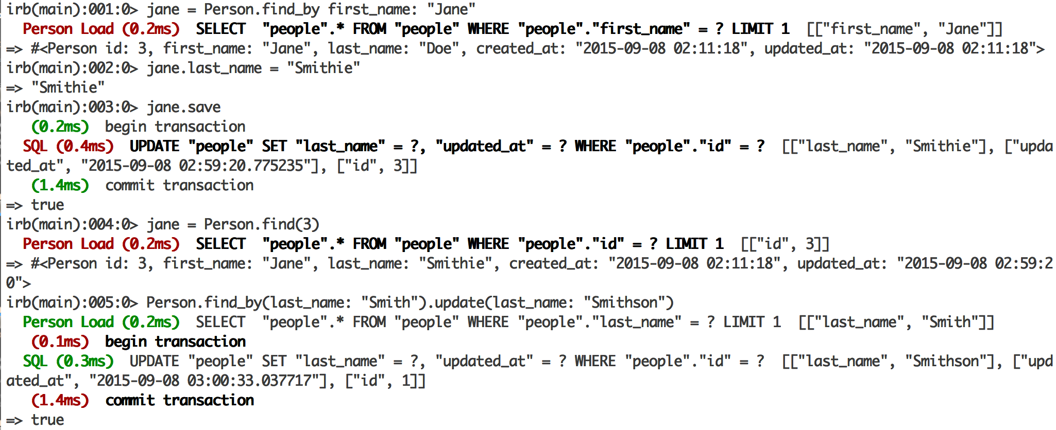

Delete (CRU*D*)

2 destroy(id) or destroy

• Removes a particular instance from the DB

• Instantiates an object first and performs callbacks before

removing

• See http://guides.rubyonrails.org/active_record_callbacks.html

2 delete(id)

• Removes the row from DB

2 There is also a delete_all

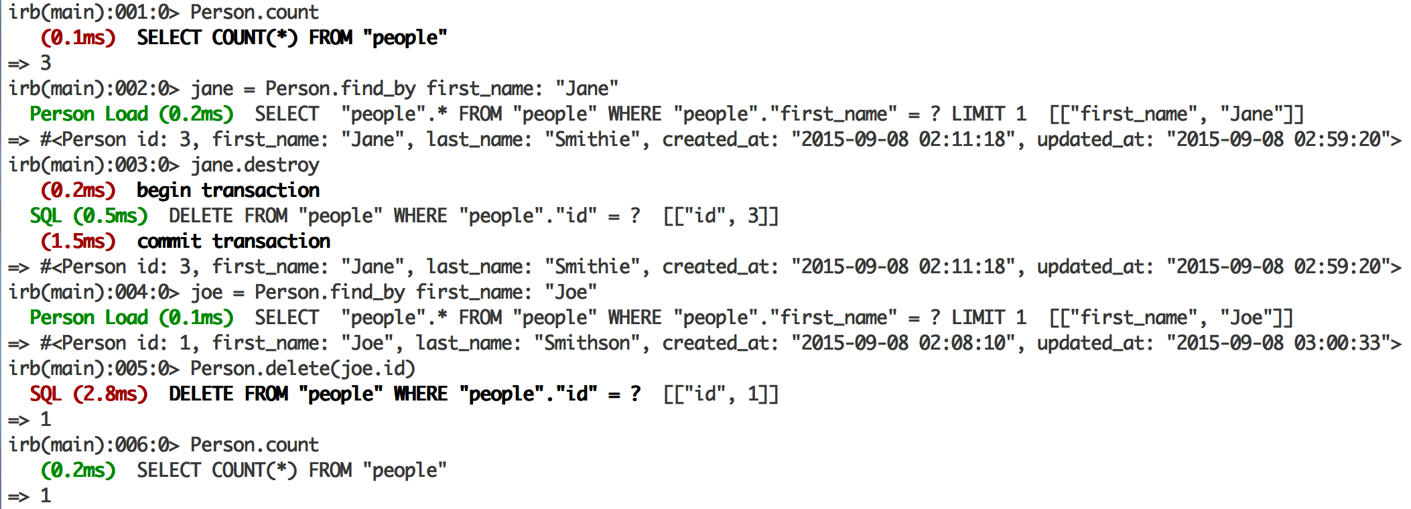

Week2

Seeding the Database

Setup people table

Rails g model person first_name age:integer last_name

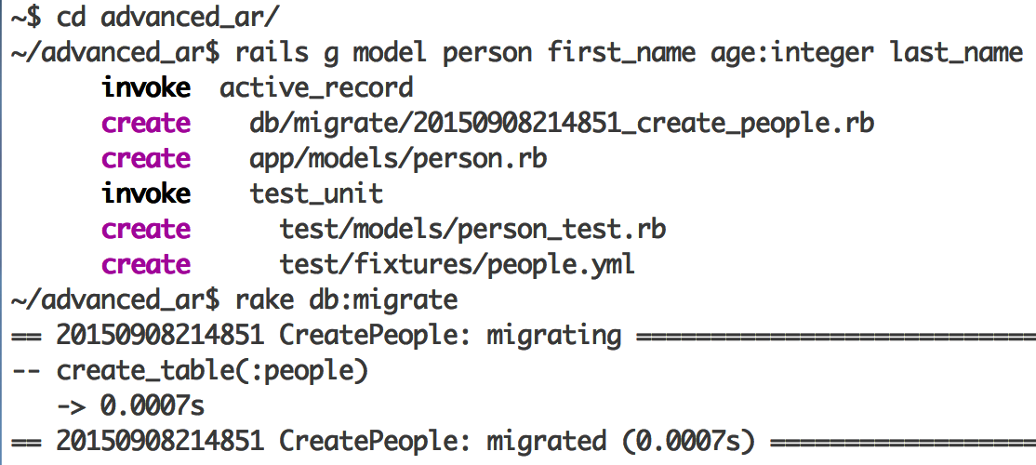

db/seeds.rb

2 We covered creating the model and migration

(structure), but it would be nice to also populate

development data

2 Rails provides db/seeds.rb for precisely this purpose

2 To populate the database with some initial values – just

Run

Rake db:seed

db/seeds.rb

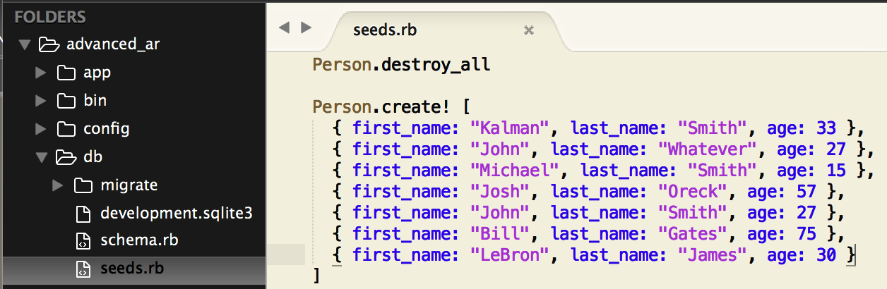

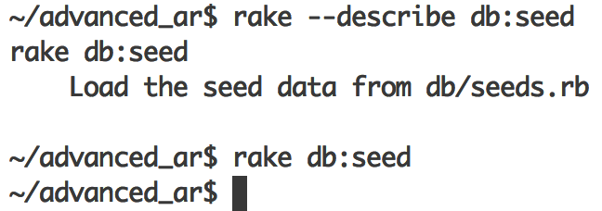

Database Populated

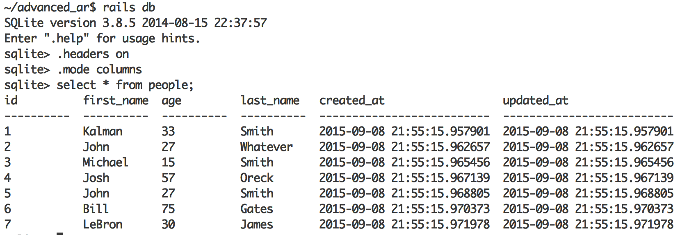

Summary

**What’s Next?**

2 db/seeds.rb lets you seed the database

2 Use create! - otherwise it will fail silently

 Dangers of SQL injection

In this lecture, we will discuss…

2 Including SQL fragments in Active Record queries

2 The dangers of SQL injection

Exact Searches

2 We already know about basic retrieves:

• find(id) or find(id1, id2)

• find_by(hash)

• where(hash)

These are nice if you know EXACTLY

what you are looking for…

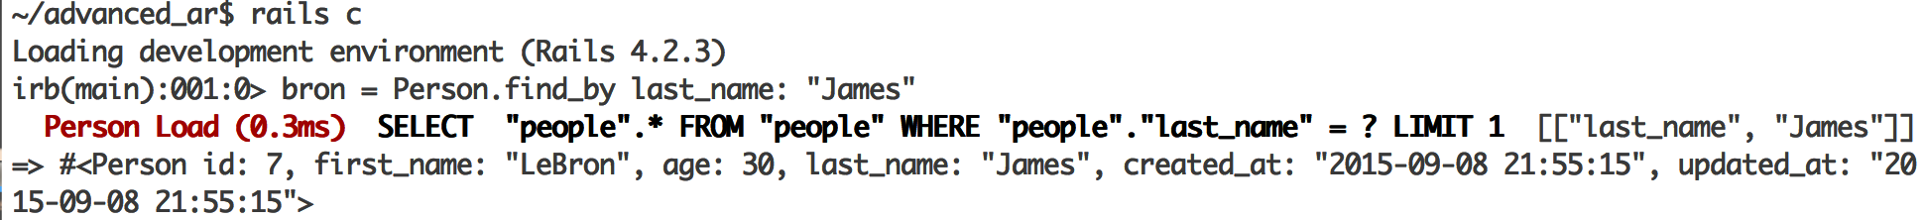

Including SQL fragments

² Can specify SQL fragment (as opposed to hash) inside

the **where and find_by**

Person.where(“age Between 30 and 33”).to_a

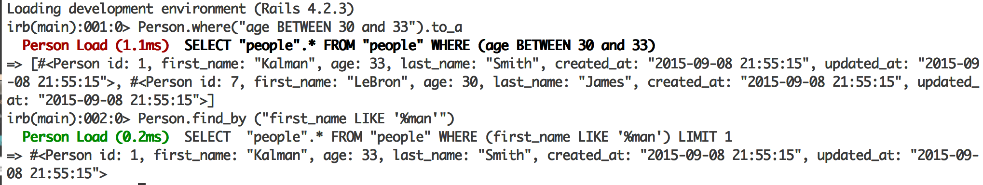

What is a SQL injection?

2 Manipulating raw SQL to hack into a database

2 This includes maliciously dropping/deleting tables or

gaining access to confidential information

2 https://en.wikipedia.org/wiki/SQL_injection

2 Quick demo…

Modify People Table

2 Add login and pass fields to people table

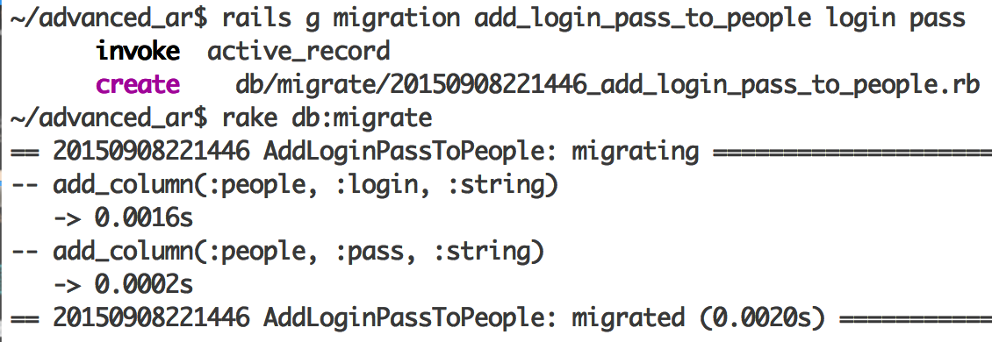

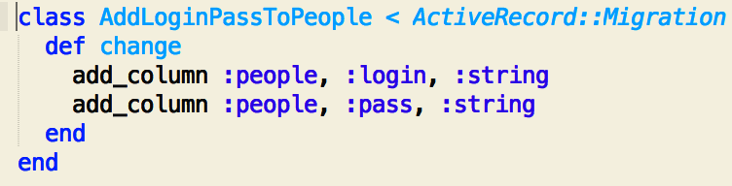

Reload Data

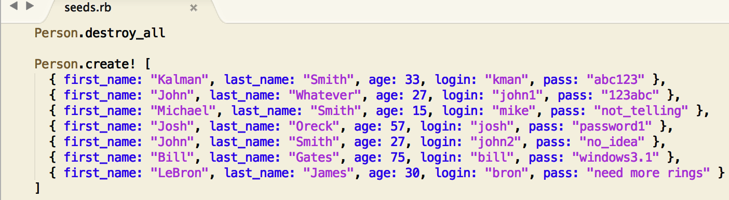

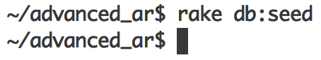

Verifying The New Data

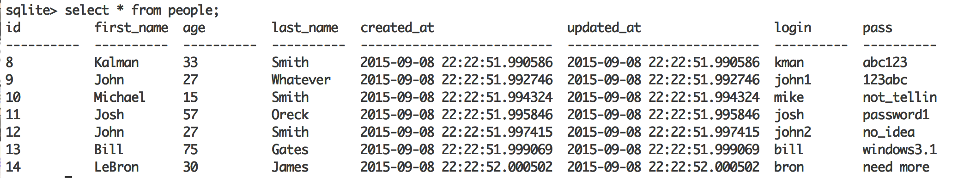

SQL Injection Example

2 **Our app wants:** Pull out the information for a particular

user based on his/her credentials

2 **Hacker wants:** ALL users/passwords!

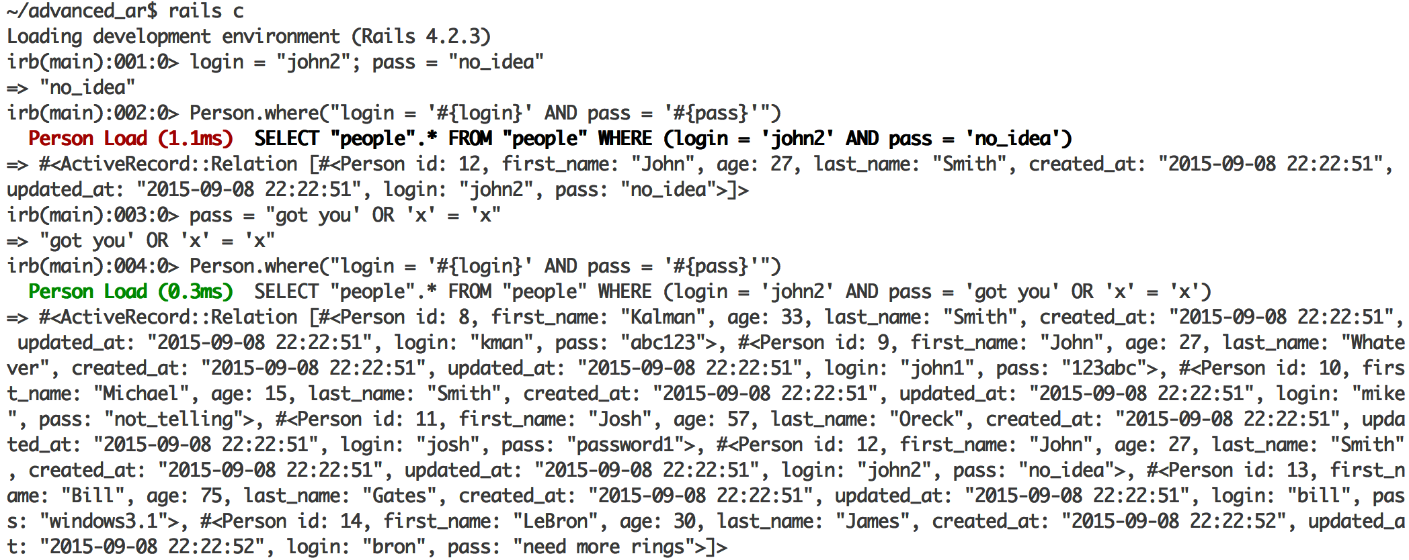Hacking is trying to inject a ruby code ‘x’ == ‘x’ which will return true for the password

Summary

Can easily include SQL fragments in queries

2 Unfortunately, this approach can leave one susceptible

to SQL injection

What’s Next?

² Array and Hash parameters to avoid SQL injection

In this lecture, we will discuss…

2 Two alternatives to directly specifying SQL literals

• Array Condition Syntax

• Hash Condition Syntax

Array Syntax

2 Lets you specify SQL fragment with ? followed by

values (parameters)

2 “Automagically” performs conversions on the input

values and escapes strings in the SQL

2 Immune to SQL injection

2 Similar to a PreparedStatement in Java

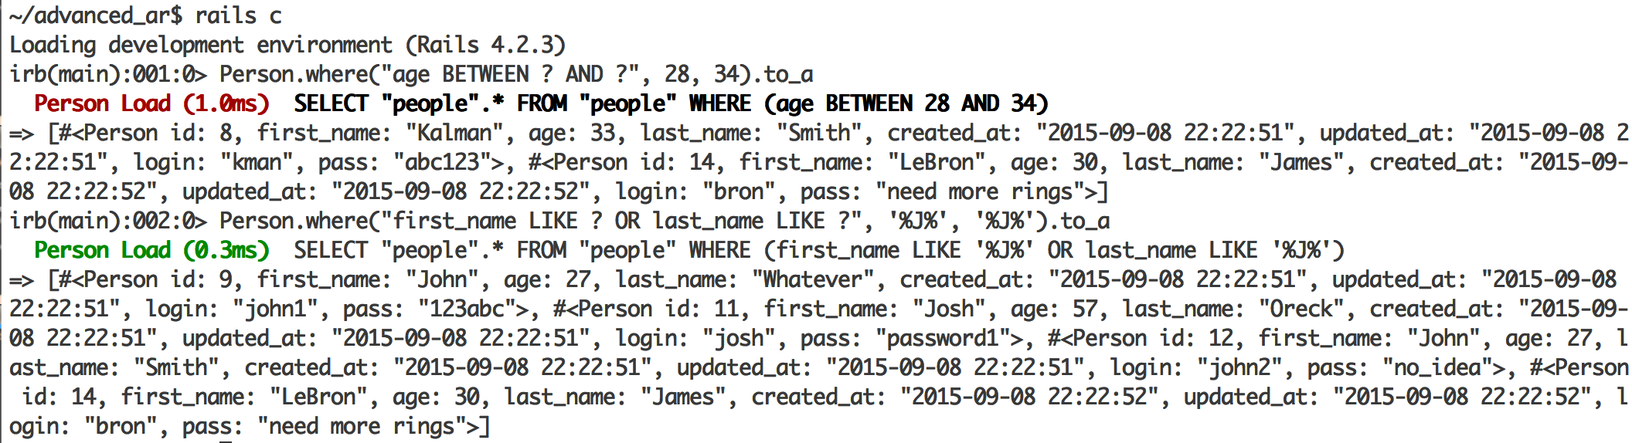

Array Condition Syntax issues

2 Array Condition Syntax is “SQL Injection safe” and easy

to use, but there are now two (small) problems:

1. You have to keep track of the order of parameters “hiding”

behind the “?”

2. If you have *n* “?” – you need to pass in *n* values, even if

they are a reference to the same value

Hash Condition Syntax

2 Instead of “?”, you specify symbols which map to the

values in the hash passed in as a second parameter

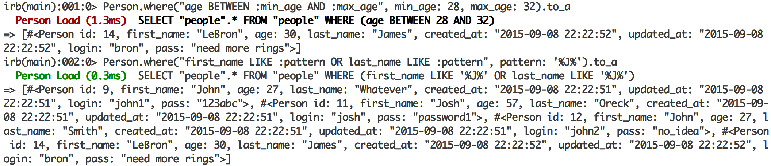

Summary

Always use either the Array or Hash Condition Syntax to

avoid SQL injection

Hash syntax seems more intuitive to most people

Expressing Database Relationships

RDBMS

Relational database management system

Relational aspect of RDBMS

2 One-to-One Association/

Relation

Relationships

2 ActiveRecord is pretty awesome so far, but what about

the relational aspect of the database?

2 The individual Ruby models map pretty well to individual

tables in the database, but how easy is it to maintain

database relations and build on them?

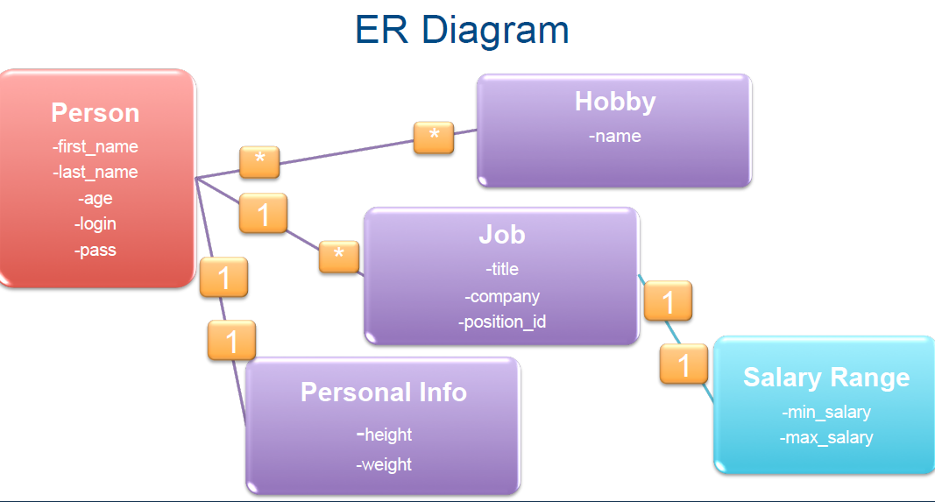

One-to-One Association

2 One person has exactly one personal_info entry

2 One personal_info entry belongs to exactly one person

2 The “*belongs to*” side is the one with a foreign key

Convention: Default name for the

foreign key is {master_table_singular}

_id, e.g. person_id

One-to-One Association

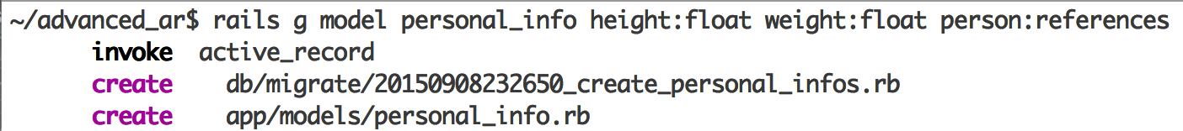

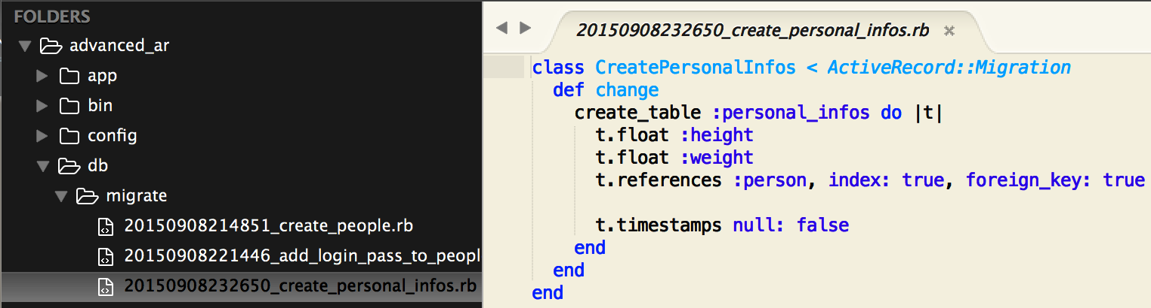

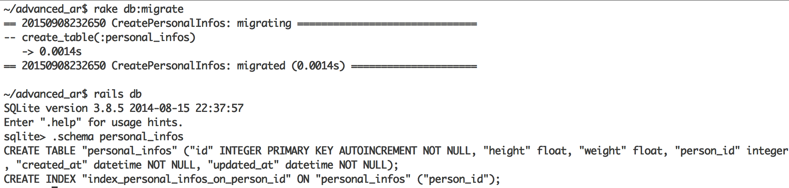

“Foreign key” to people table

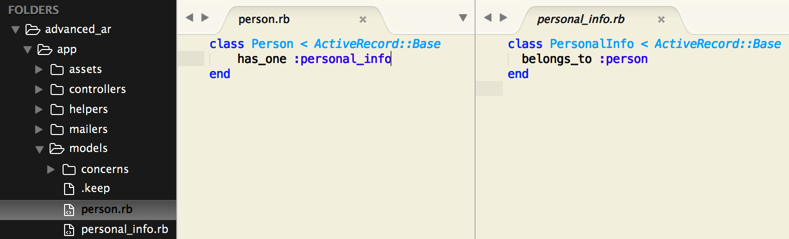

One-to-One Association

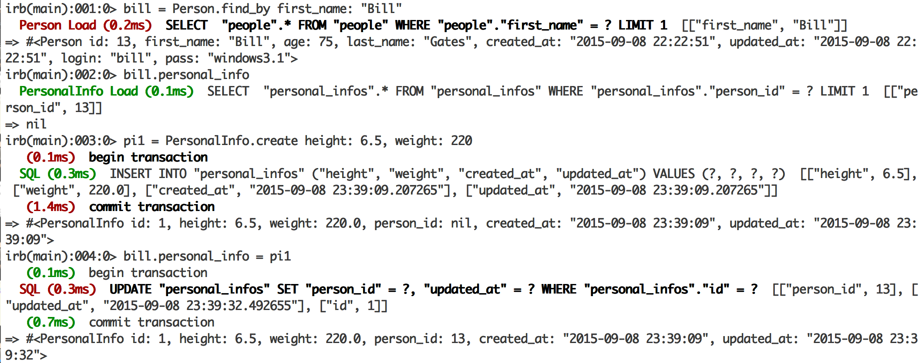

Person and PersonalInfo

2 In addition, you now also have

build_personal_info(hash) and

create_personal_info(hash) methods on a person

instance

2 create_personal_info creates a record in the DB

right away, while build_personal_info does not

2 Both remove the previous reference in the DB

build_personal_info / create_personal_info

